Formulario: Rudik Rompich

Capítulo 3

1. Descubrimiento rayos X – Electrón

1. Carga del electrón
2. Línea espectral

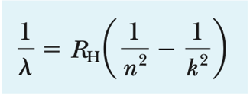

Figure - Máxima difracción

Figure - Rydberg

1. Cuantización
2. A picture containing text

   Description automatically generatedA picture containing calendar

   Description automatically generatedText

   Description automatically generated with medium confidenceText

   Description automatically generatedText

   Description automatically generatedRadiación de cuerpo negro

Figure -Radiación de Planck

Figure - Rayleigh-Jeans

Figure - Stefan-Boltzmann

Figure - Wien desplazamiento

1. Efecto fotoeléctrico

Einstein

Cuántico



1. Text

   Description automatically generated with medium confidenceProducción de X-Ray

Figure -Duane-Hunt

1. Efecto Compton

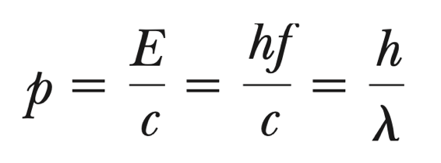

z

1. Producción de pares y aniquilación

Capitulo 4

1. Estructura del átomo
2. Rutherford

1. Modelo atómico clásico

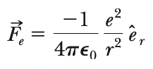

1. Modelo de Bohr del átomo de hidrógeno

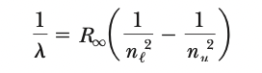

1. El principio de correspondencia

1. Errores del modelo de Bohr - Reducción de masa

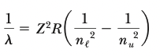

1. Espectro Rayos-X y número atómico

